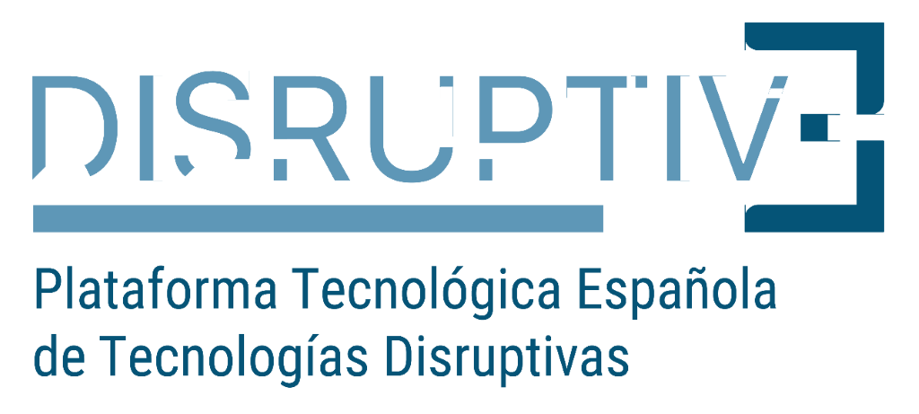 activity financed by:

COLLABORATION FORM

ID | Indicate here if it is about offer or demand for collaboration
DATE
TITLE
COUNTRY
COMPANY
PCT | Indicate here if the company is located in a science-technology park or if it is not
ACTIVITY SECTOR
TYPE OF COLLABORATION
SERVICES THAT ARE OFFERED OR DEMANDED
DESCRIPTION OF THE CAPABILITIES THAT THE COMPANY MUST HAVE
TYPE OF AGREEMENT
ADDITIONAL INFORMATION
COMPANY INFORMATION
WEB ADDRESS
ENTITY LOGO

DISRUPTIVE PLATFORM PRIVACY POLICY

We inform you that your personal data will be processed by the Association of Science and Technology Parks of Spain (APTE) for the management of your application for membership of the Spanish Technological Platform for Disruptive Technologies, DISRUPTIVE.

Likewise, the institutional data of the entity will be published in the "MEMBERS" section of the website of the platform www.ptedisruptive.es. In addition, these data may be used to send you by any means (electronic or not), information about activities / news, courses, programs and any type of information related to the activity of DISRUPTIVE.

You have at your disposal the possibility of exercising the rights of access, rectification, deletion, limitation to treatment, opposition and portability; that you can make effective by writing to the Association of Science and Technology Parks of Spain - APTE, at the address Calle María Curie, 35, CP 29590 de Campanillas, Málaga; or at the email address: info@apte.org In any situation, you will have the right to file a claim with the Spanish Agency for Data Protection (AEPD).

The data is not disclosed to any third party outside APTE. The data will be kept as long as the Spanish Technological Platform for Disruptive Technologies (DISRUPTIVE) is active and, in any case, in compliance with the applicable statutory limitation periods.

Responsible for the Treatment: Association of Science and Technology Parks of Spain (APTE) C / Marie Curie, nº 35, 29590, Málaga. CIF no. G33216961.

